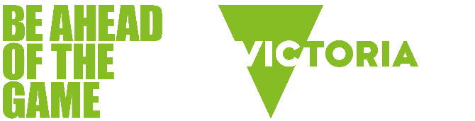

Be Ahead of the Game - classroom resources summary

Introduction
Be Ahead of the Game provides Victorian teachers with free, curriculum-aligned classroom resources to help students understand the risks associated with gambling and gaming. All units are professionally developed in partnership with experts in education and resource development and are designed to be engaging, user-friendly, and support the Victorian school curriculum.

Empowering young people to understand gambling risks
Gambling harm among young people is a growing concern. Research shows that both exposure to gambling and participation are on the rise. Schools play a vital role in addressing this issue. Our classroom-ready resources make it easy for teachers to deliver engaging lessons that spark discussion and encourage active participation. These lessons help students understand gambling, its risks, and how to make informed choices.

Victorian Certificate of Education (VCE) Vocational Major (VM)

VCE VM Literacy

Love the Game (Unit 1)
Develop a presentation pitch to convince a sporting club to sign up to the Love the Game sporting club program and say ‘no’ to sports betting sponsorship.

Potential influences (Unit 3)
Considers the influences that shape their own and the wider community’s attitudes toward gambling.

VCE VM Personal Development Skills

Knowing the score (Unit 2)
Students create a product to help their peers understand the risks of gambling.

Knowing when it’s a concern (Unit 4)
Students develop a community engagement activity to increase understanding and awareness of gambling harm and support services.

VCE VM Numeracy

Finances and gambling (Unit 1):
Builds mathematical skills used for managing household and living expenses while exploring the financial harm that gambling can cause.

What are the chances? (Unit 2)
Explores chance and probability to help students develop informed attitudes toward gambling.

Earnings and expenditure (Unit 3)
Investigates the impact gambling losses have on Australians while providing key information students need to know about getting their first job including paying tax, superannuation, workplace rights, and payslips.

Odds and probability (Unit 4)
Deep dives into the way gambling really works. Teaches students about the randomness of gambling and to think critically about gambling products.

VCE

VCE Health and Human Development (Unit 1)

‘GAME ON.’ Gambling – a youth health issue
Focuses on the health and wellbeing of young Australians and helps students develop an understanding of help-seeking strategies for anyone experiencing problems related to gambling.

VCE Media studies (Units 1 and 2)

Representations of gambling in advertising

Explores gambling advertising. Students discuss the values represented in betting ads, and how they are designed to appeal to target audiences.

Years 7 to 10

Health and Physical Education (Years 7–10)

Lessons that help students learn about the risks and realities of gambling and gaming to help them make informed decisions. Students will gain insights into the impact of gambling on the broader community.

Humanities (Year 10)

The role of regulation

Highlights the risks of gambling and how regulation helps to protect individuals from gambling harm.

Risky business

Helps students understand the financial risks associated with gambling and how recognising the limited chances of winning can protect them from harm.

Years 5 and 6

The Bridge
A school education program about the risks of online gaming. A creative program developed for upper primary school students that explores the potential risks of online gaming. The Bridge caters for all teachers, regardless of their knowledge and experience of gaming.
The innovative program includes:
- Victorian curriculum links
- detailed lesson plans
- animated videos and kinaesthetic learning activities
- strategies for managing risks and keeping kids safe.
For more information about Be Ahead of the Game classroom resources, visit beaheadofthegame.vic.gov.au

