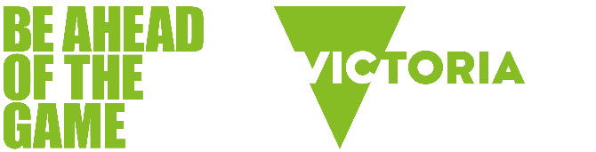

The Bridge: A school education program about the risks of online gaming.
  - FINALIST 2022 VicHealth Future Healthy Award

Introduction
The Bridge is a free, creative program for upper primary school students that explores the potential risks of online gaming. It has been developed for use by all teachers, regardless of their knowledge and experience of gaming.
The program includes:
- Victorian curriculum links (levels 5 and 6)
- teaching resources, including starters, discussion themes, learning intentions
- animated videos and kinaesthetic learning activities
- strategies for managing risks and staying safe.

Quote from Jess and Chris, Teachers from Altona North Primary School:
The Bridge Program is an incredible opportunity for students to develop a deep understanding about the risks of online gaming through engaging learning tasks.

What is The Bridge?
The Bridge is the name of a fictitious online video game. Throughout the program, students follow the journey of a character named Helmette, who becomes increasingly drawn into the game at the expense of their time, relationships and wellbeing. The Bridge not only raises young people’s awareness and understanding of the potential risks associated with online gaming, which also apply to gambling, it provides them with tools to manage the risks.

What are the risks of gaming?
Online games can be fun, creative, and good for children’s emotional, social and cognitive development. But there are also risks.
The Bridge program’s whole-of-school approach helps kids, parents, carers and teachers to understand:
- how games can trick us into playing longer and spending more money than intended
- the gambling-like elements in games, such as loot boxes
- why it can be difficult to stop gaming
- when a young person’s online gaming might be affecting their wellbeing.

What is excessive video gaming?
It’s difficult to put an exact figure on how much gaming is too much, which is why it is important to be alert to negative warning signs children may display. These can include:
- prioritising gaming over all other activities
- losing interest in school, friends or hobbies
- difficulty sleeping and poor eating habits
- becoming angry when asked to stop gaming.

Bring The Bridge into your classroom
Visit beaheadofthegame.vic.gov.au/thebridge to find out more and download the free teaching resources.

Acknowledgements
The Bridge was developed in partnership with the Victorian Department of Health and Kids Thrive with additional funding from Creative Victoria.
For more information about Be Ahead of the Game classroom resources, visit beaheadofthegame.vic.gov.au.

