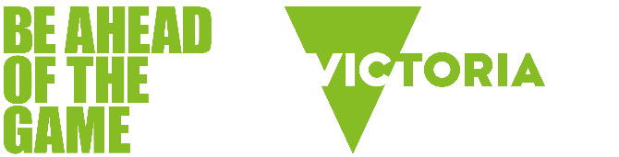

Gambling awareness workshops for secondary schools

How to get your school involved
Victorian secondary schools can book any of our free Be Ahead of the Game workshops. Online or in-classroom, our interactive workshops are tailored to each year level and delivered by highly experienced community educators who specialise in educating young people about gambling risks.

Book a free workshop for:

Students
- Know the score (years 7–12)
Helps students think critically about the risks of gambling and examines the factors that influence their attitudes toward gambling.
- When gaming meets gambling (years 7–12)
Explores the increasingly blurry line between gaming and gambling, helping students stay healthy, happy and safe.
- Your money matters – Financial literacy (years 9–12)
Helps students develop financial literacy skills while understanding the negative consequences of gambling.

Parents and carers
- Talking to young people about gambling
Focuses on the issue of young people and gambling and provides parents and carers with practical advice on how to talk to young people about it.
- Talking to young people about gaming
Helps parents understand the way gambling has been integrated into gaming, and the risks of exposing young people to gambling-like features such as loot boxes, social casino games and microtransactions.

Teachers
- Support your students to think critically about gambling
Provides teachers with an understanding of the youth-related issues associated with gambling and gaming and offers strategies for developing a whole-of-school approach to the issue.

What is Be Ahead of the Game?
Be Ahead of the Game is a free school education program helping secondary school students think critically about gambling. Informed by latest research, the Victorian Government program not only teaches young people about the risks and realities of gambling, but supports parents, carers and educators to talk to kids about it.

What Victorian teachers and students are saying about Be Ahead of the Game workshops

Teacher survey results
- 100% of teachers* said they would recommend Be Ahead of the Game student workshops to other teachers/schools.
* Based on surveys of over 184 teachers in 2024/5.

Student survey results
Percentage of students* who said they had a ‘good’ or ‘very good’ understanding of:
- where people can go to get help for gambling harm is between 83% and 95%
- the signs that someone is experiencing gambling harm is between 84% and 94%
- how gambling can affect someone’s wellbeing is between 89% and 96%
- how gambling can affect a community is between 82% and 92%
*Based on surveys of over 5,500 students who completed a Be Ahead of the Game workshop in 2024/5.

Quotes from Victorian teachers about Be Ahead of the Game workshops

- ‘Such an important topic for students to consider and be educated about. The presentation was at the level of the students and there was lots of chat between students on what they were learning about.’

- ‘An eye-opening presentation exposing students to new information and concepts.’

- ‘Great to have a presenter who knows about the topic and can engage students in it.’

- ‘The presentation was a good length for students and utilised a variety of methods to keep the session engaging and appropriate.’

Scan to book a free workshop or visit beaheadofthegame.vic.gov.au for more info. Alternatively, email us at beaheadofthegame@health.vic.gov.au

