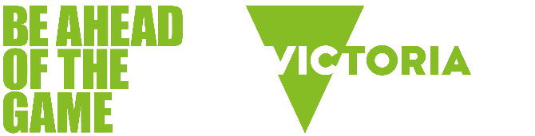

Understanding and recognising gambling harm

What is gambling harm?
Gambling harm is any negative consequence experienced by an individual or their friends and family because of participation in gambling.
Types of gambling harm include:
- relationship difficulties
- health problems
- emotional or psychological distress
- financial problems
- issues with work or study
- cultural problems
- criminal activity.
These harms can be experienced on a spectrum from no harm at all, through to very severe harm. They can range from minor negative experiences to crisis point, which is often when people consider seeking professional help for their gambling.

How a person's gambling can affect those around them
Gambling problems don't just affect the person who gambles. People affected by someone else's gambling include intimate partners, family members, friends, colleagues and others.
Harms commonly reported by people affected by someone else's gambling include:
- feeling angry or hopeless
- experiencing relationship conflict with the person who gambles
- experiencing stress, worry, and loss of sleep
- late payment of bills, such as utilities and rates
- less money for essential expenses such as medication, health care, and food
- having money or items stolen.
In Victoria, females aged between 25 and 44 years are more likely to be affected by someone else's gambling.
Source | Suomi, A. et al, 2024, Victorian population gambling and health study 2023 - Factsheet 6, State Government of Victoria, Melbourne.

Signs of gambling harm
Signs of a gambling issue can include:
- being unexpectedly moody and irritable
- spending less time doing family things
- no longer going out or socialising
- talking about betting a lot
- obsessed with the odds when watching sport
- missing school or work.

Support options for people experiencing gambling harm
People can seek support for gambling problems at any time - whether they think it's a mild concern or a serious issue.
Victorians experiencing gambling harm, including those who are affected by someone else’s gambling, have a range of options for information, advice and support. All support options listed below are anonymous, free and confidential.
Types of support available
- Phone support via the Gambler’s Help line 1800 858 858.
- Face-to-face counselling, including financial counselling.
- Under 25s counselling and phone support - Gambler’s Help Youthline or 1800 262 376.
- Support from people with personal experience of gambling harm - Peer Connection.
- Online chat and email support - Gambling Help Online.
- Self-help tools.
- Self-exclusion programs for people who wish to ban themselves from gambling venues and websites.

Find more support options

